Hi Amit ,
Pls find attached query and schema meeting following conditions :
1. tech support page, japanese locale, first show Japanese records then english documents(blank searches)
2. Japanese character query(オシロスコープ), japanese locale, show japanese document, no english documents
3,4. english query, japanese locale, show japanese documents(some fields in english) + english documents
5. unique documents on the basis of PUBKEY
8 languages support

1. Tech support page, JA locale, first JA records the then en documents(blank searches) (by passing * in query) and Locale as JA

2. Japanese query(オシロスコープ), japanese locale, japanese document, no english documents (japanese query with JA locale)

3,4. english query, japanese locale, japanese documents(some fields in english) + english documents (english query with JA locale)

5. unique documents on the basis of PUBKEY. This has been ensured by collapse functionality

6. Language Detection:
Elastic search doesn't provide on the fly language detection. It is also not recommended by elastic search.
https://www.elastic.co/blog/multilingual-search-using-language-identification-in-elasticsearch
Cannot do language detection at query layer can only be done at index level.
But we achieved desired results with this query .

Query with explanation:

{
"_source": "false",
"from": 0,
"size": 100,
"query": {
"bool": {
"minimum_should_match": 1,
"should": [
{
"term": {
"PUB_SUFFIX.keyword": {
"value": "JA",<LOCALE>
"boost": 40
}
}
},
{
"term": {
"PUB_SUFFIX.keyword": {
"value": "EN"
}
}
}
],
"must": [
{
"query_string": {
"query": "software"<QUERY>
}
}
]
}
},
"collapse": {
"field": "PUBKEY.keyword",
"inner_hits": {
"name": "search_results",
"size": 1
}
}
}

Analyzer Setup Process:
Japanese (kuromoji) Analysis Plugin
The Japanese (kuromoji) Analysis plugin integrates Lucene kuromoji analysis module into elasticsearch.

Installation
This plugin can be installed using the plugin manager:
sudo bin/elasticsearch-plugin install analysis-kuromoji
Note:The plugin must be installed on every node in the cluster, and each node must be restarted after installation.
Thanks and Regards,

Hi,
Please find the process to configure language analyzers, setting up schema and query
- Setting up analyzers for Chinese, korean, japanese. Elastic search doesn't provide inbuilt analyzers for these languages, So we have to install them via plugin manager. For rest languages elastic search provides in-built analyzers.
  - sudo bin/elasticsearch-plugin install analysis-kuromoji
  - sudo bin/elasticsearch-plugin install analysis-smartcn
  - sudo bin/elasticsearch-plugin install analysis-nori
- Updating the mapping, We have to update our elastic search mapping to use these analyzers. Use this command to update the schema, It will just add a few fields in the already existing index. We have enabled language analyzers on TITLE, DESCRIPTION, CONTENT_TYPE_TITLE, KEYWORDS, CONTENT
  - POST wlm_dam/_mapping
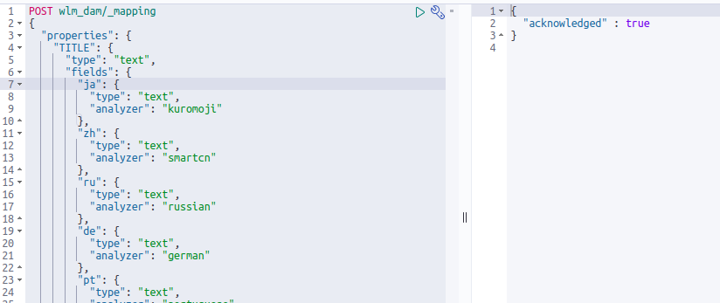<content of dam-schema-change file>
Screenshot

- Re-index the data, So that these added fields get populated.
- Query the data dam-query-draft-3 as shared in previous mail.

{
"properties": {
"TITLE": {
"type": "text",
"fields": {
"ja": {
"type": "text",
"analyzer": "kuromoji"
},
"zh": {
"type": "text",
"analyzer": "smartcn"
},
"ru": {
"type": "text",
"analyzer": "russian"
},
"de": {
"type": "text",
"analyzer": "german"
},
"pt": {
"type": "text",
"analyzer": "portuguese"
},
"en": {
"type": "text",
"analyzer": "standard"
},
"ko": {
"type": "text",
"analyzer": "nori"
}
}
},
"DESCRIPTION": {
"type": "text",
"fields": {
"ja": {
"type": "text",
"analyzer": "kuromoji"
},
"zh": {
"type": "text",
"analyzer": "smartcn"
},
"ru": {
"type": "text",
"analyzer": "russian"
},
"de": {
"type": "text",
"analyzer": "german"
},
"pt": {
"type": "text",
"analyzer": "portuguese"
},
"en": {
"type": "text",
"analyzer": "standard"
},
"ko": {
"type": "text",
"analyzer": "nori"
}
}
},
"CONTENT_TYPE_TITLE": {
"type": "text",
"fields": {
"ja": {
"type": "text",
"analyzer": "kuromoji"
},
"zh": {
"type": "text",
"analyzer": "smartcn"
},
"ru": {
"type": "text",
"analyzer": "russian"
},
"de": {
"type": "text",
"analyzer": "german"
},
"pt": {
"type": "text",
"analyzer": "portuguese"
},
"en": {
"type": "text",
"analyzer": "standard"
},
"ko": {
"type": "text",
"analyzer": "nori"
}
}
},
"KEYWORDS": {
"type": "text",
"fields": {
"ja": {
"type": "text",
"analyzer": "kuromoji"
},
"zh": {
"type": "text",
"analyzer": "smartcn"
},
"ru": {
"type": "text",
"analyzer": "russian"
},
"de": {
"type": "text",
"analyzer": "german"
},
"pt": {
"type": "text",
"analyzer": "portuguese"
},
"en": {
"type": "text",
"analyzer": "standard"
},
"ko": {
"type": "text",
"analyzer": "nori"
}
}
},
"CONTENT": {
"type": "text",
"fields": {
"ja": {
"type": "text",
"analyzer": "kuromoji"
},
"zh": {
"type": "text",
"analyzer": "smartcn"
},
"ru": {
"type": "text",
"analyzer": "russian"
},
"de": {
"type": "text",
"analyzer": "german"
},
"pt": {
"type": "text",
"analyzer": "portuguese"
},
"en": {
"type": "text",
"analyzer": "standard"
},
"ko": {
"type": "text",
"analyzer": "nori"
}
}
}
}
}

{
"_source": "false",
"from": 0,
"size": 100,
"query": {
"bool": {
"minimum_should_match": 1,
"should": [
{
"term": {
"PUB_SUFFIX.keyword": {
"value": "JA",
"boost": 40
}
}
},
{
"term": {
"PUB_SUFFIX.keyword": {
"value": "EN"
}
}
}
],
"must": [
{
"query_string": {
"query": "ソフトウェア"
}
}
]
}
},
"collapse": {
"field": "PUBKEY.keyword",
"inner_hits": {
"name": "search_results",
"size": 1
}
}
}

